01)

START TRANSACTION;

INSERT INTO customer(Id, FirstName, LastName, City, Phone)

VALUES('92', 'Alex', 'Perera', 'Colombo', 'Sri Lanka', '077-1231234');

COMMIT;

SELECT*FROM customer;

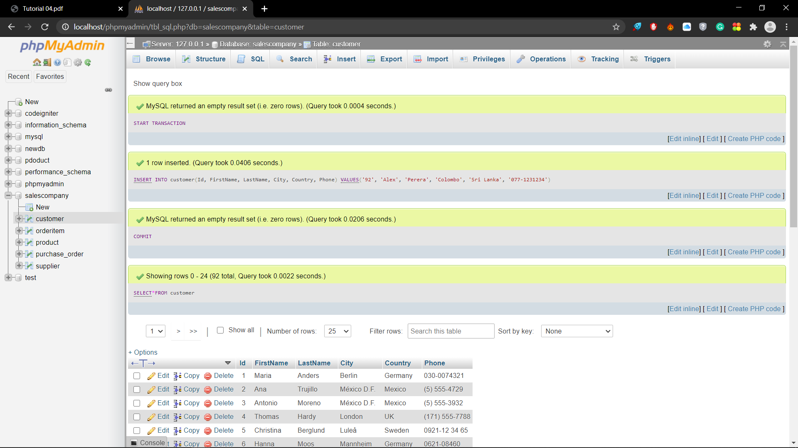

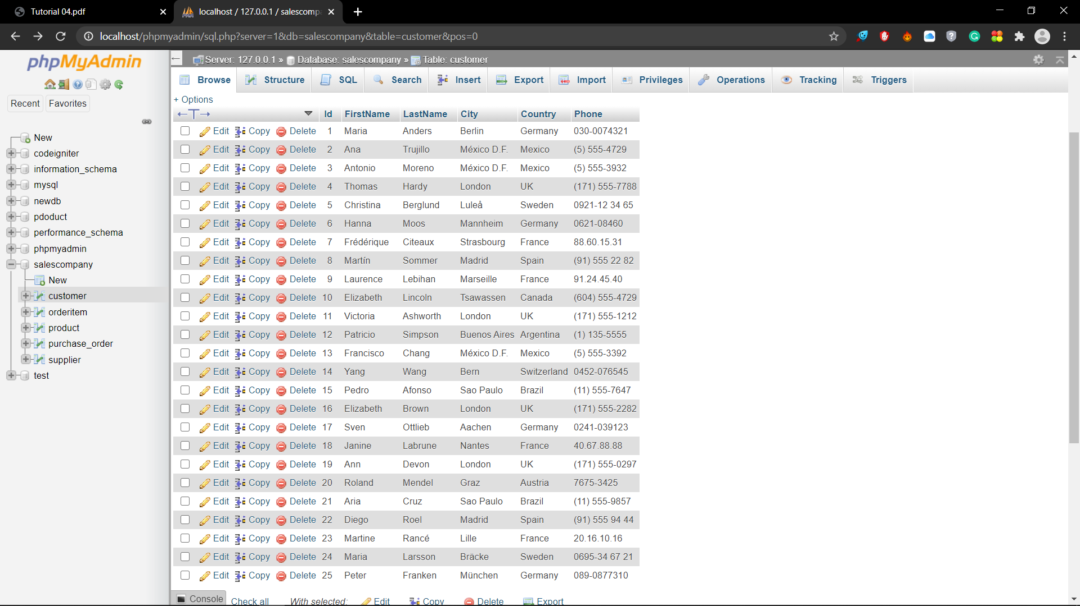

02)

START TRANSACTION;

INSERT INTO customer(Id, FirstName, LastName, City, Country, Phone)

VALUES('93', 'Alexian', 'Fedrick', 'Chilaw', 'Sri Lanka','077-1112223');

ROLLBACK;

SELECT*FROM customer;

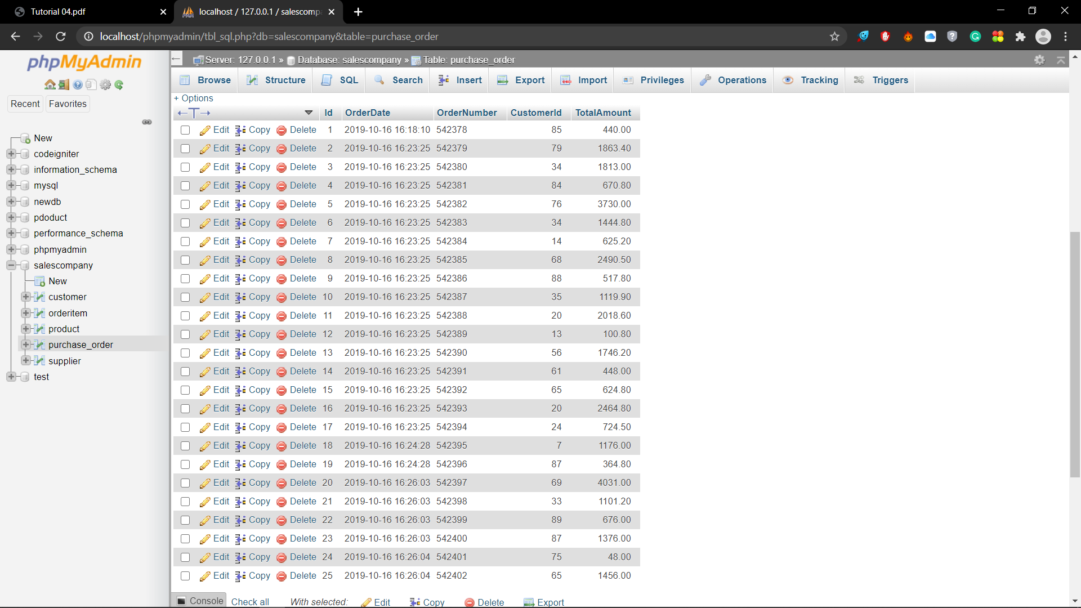

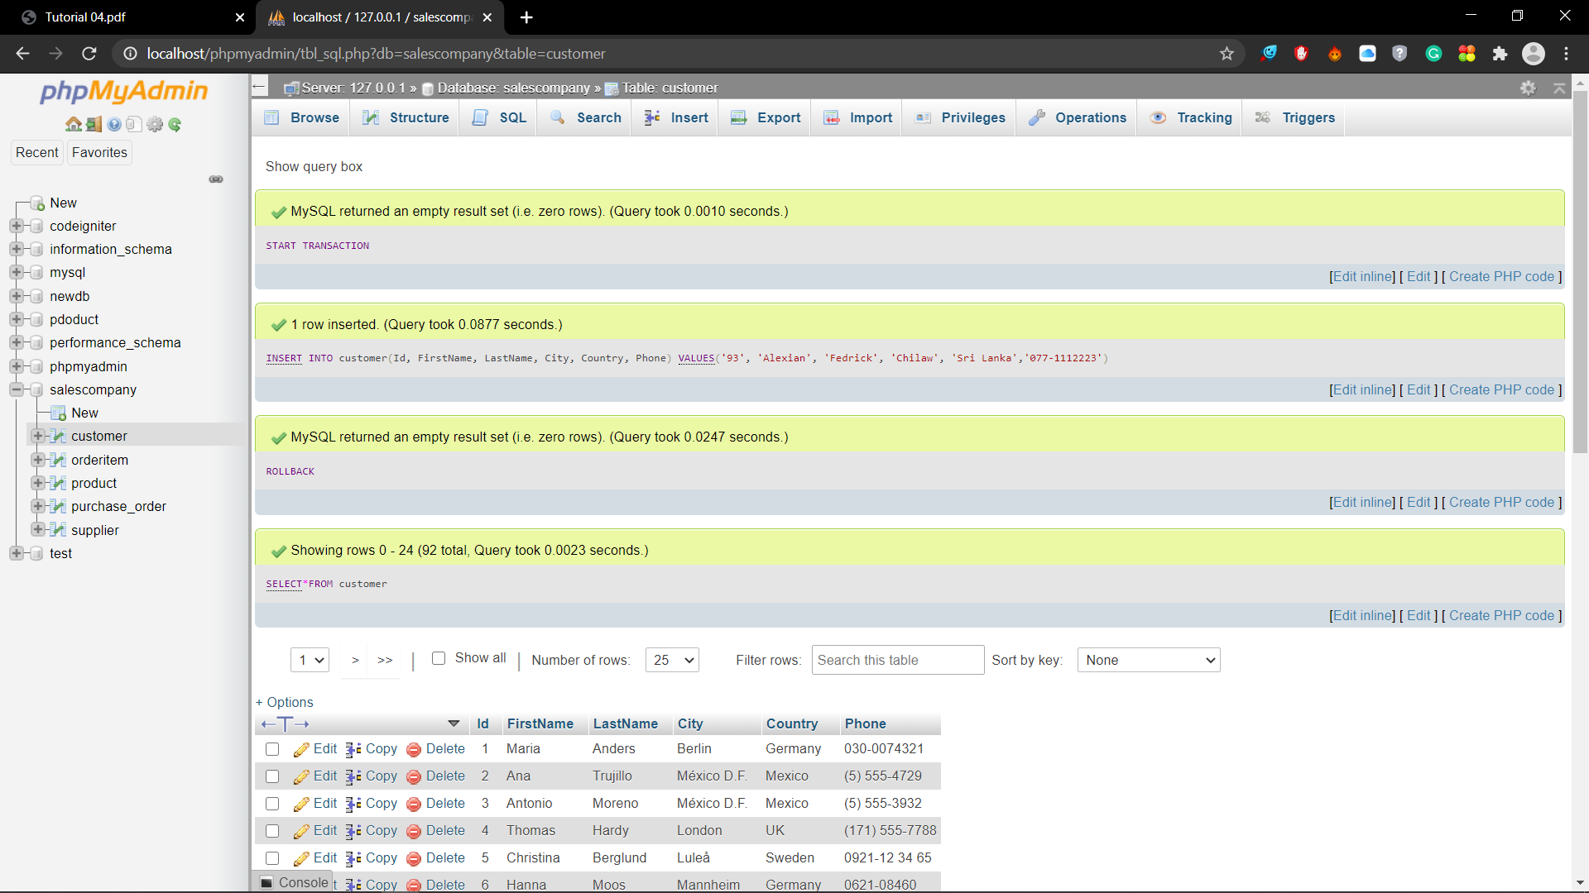

03)

START TRANSACTION;

INSERT INTO purchase_order(Id, OrderDate, OrderNumber, CustomerId, TotalAmount)

VALUES('43', '2020-10-16', '542420', '51', '2100.00');

INSERT INTO orderitem (Id, OrderId, ProductId, UnitPrice, Quantity)

VALUES ('145', '43', '79', '210.00', '10');

COMMIT;

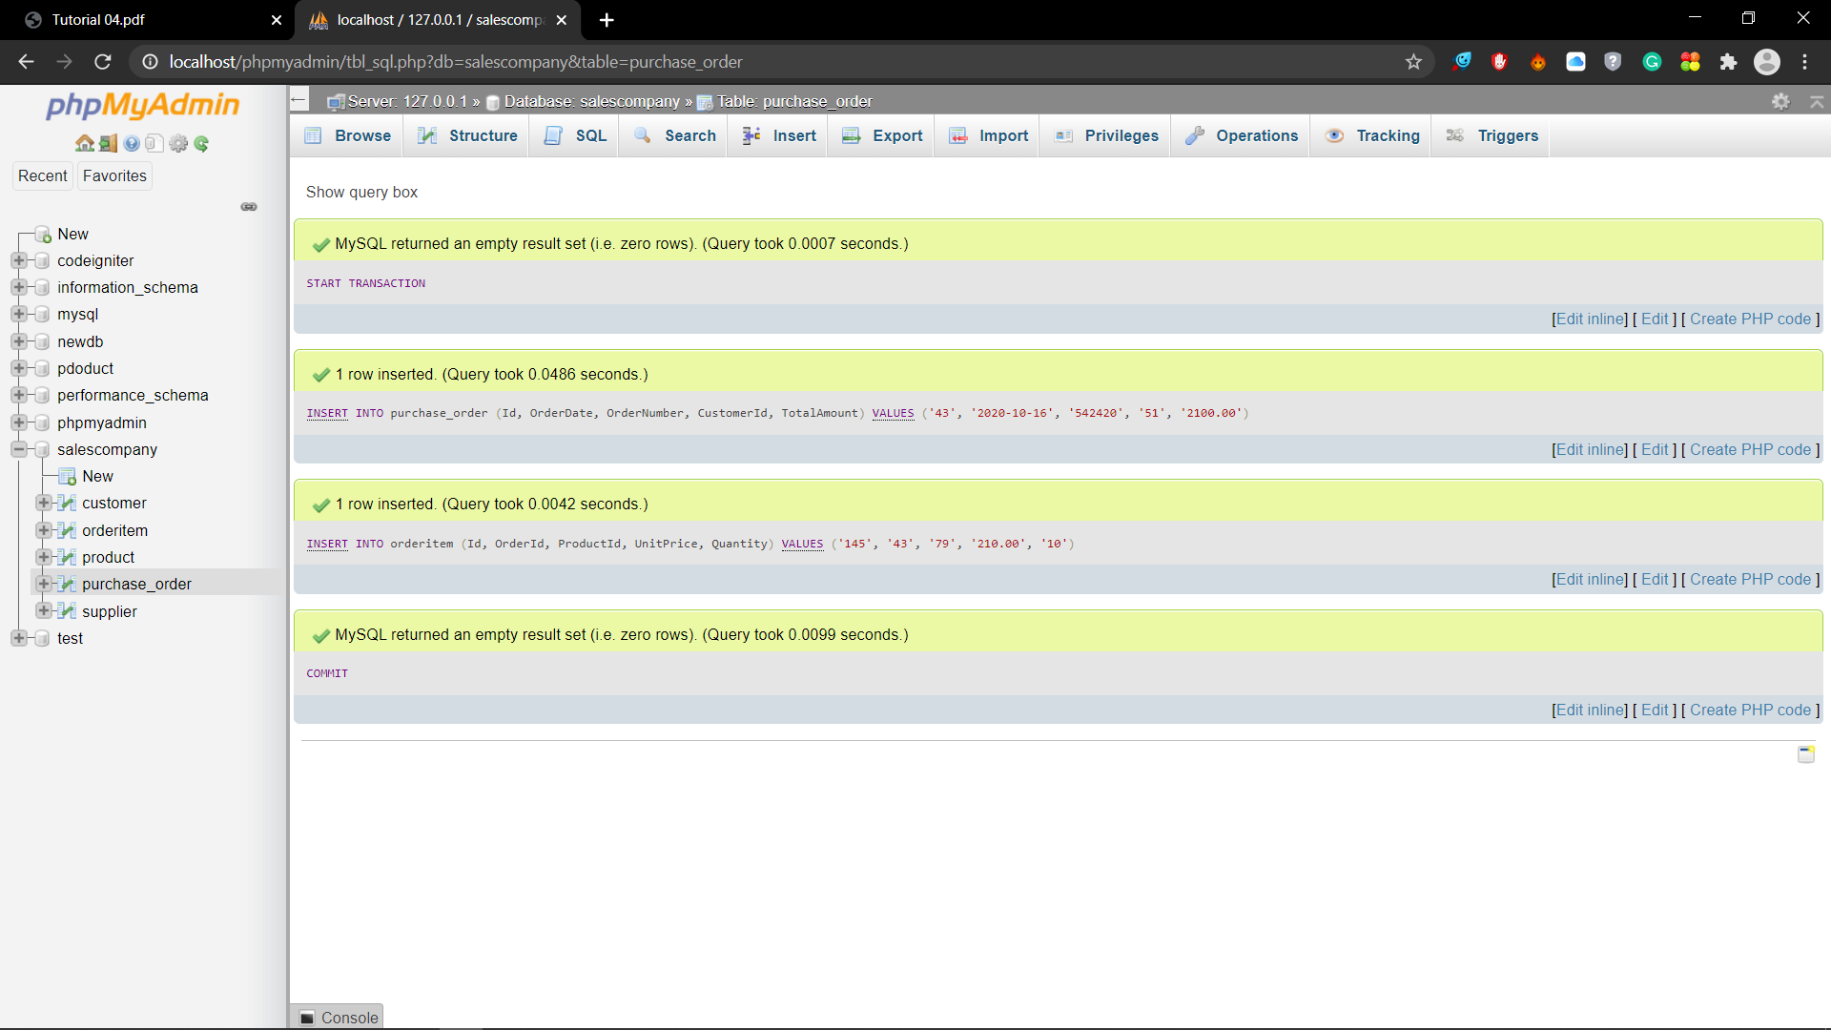



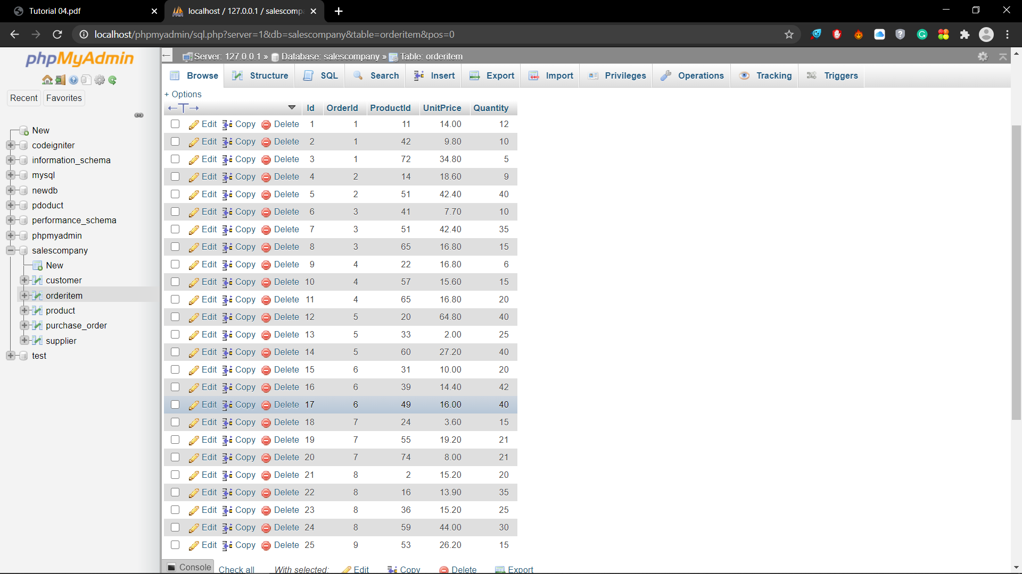

04)

START TRANSACTION;

DELETE FROM purchase_order WHERE CustomerId='63';

COMMIT;

SELECT * FROM purchase_order;

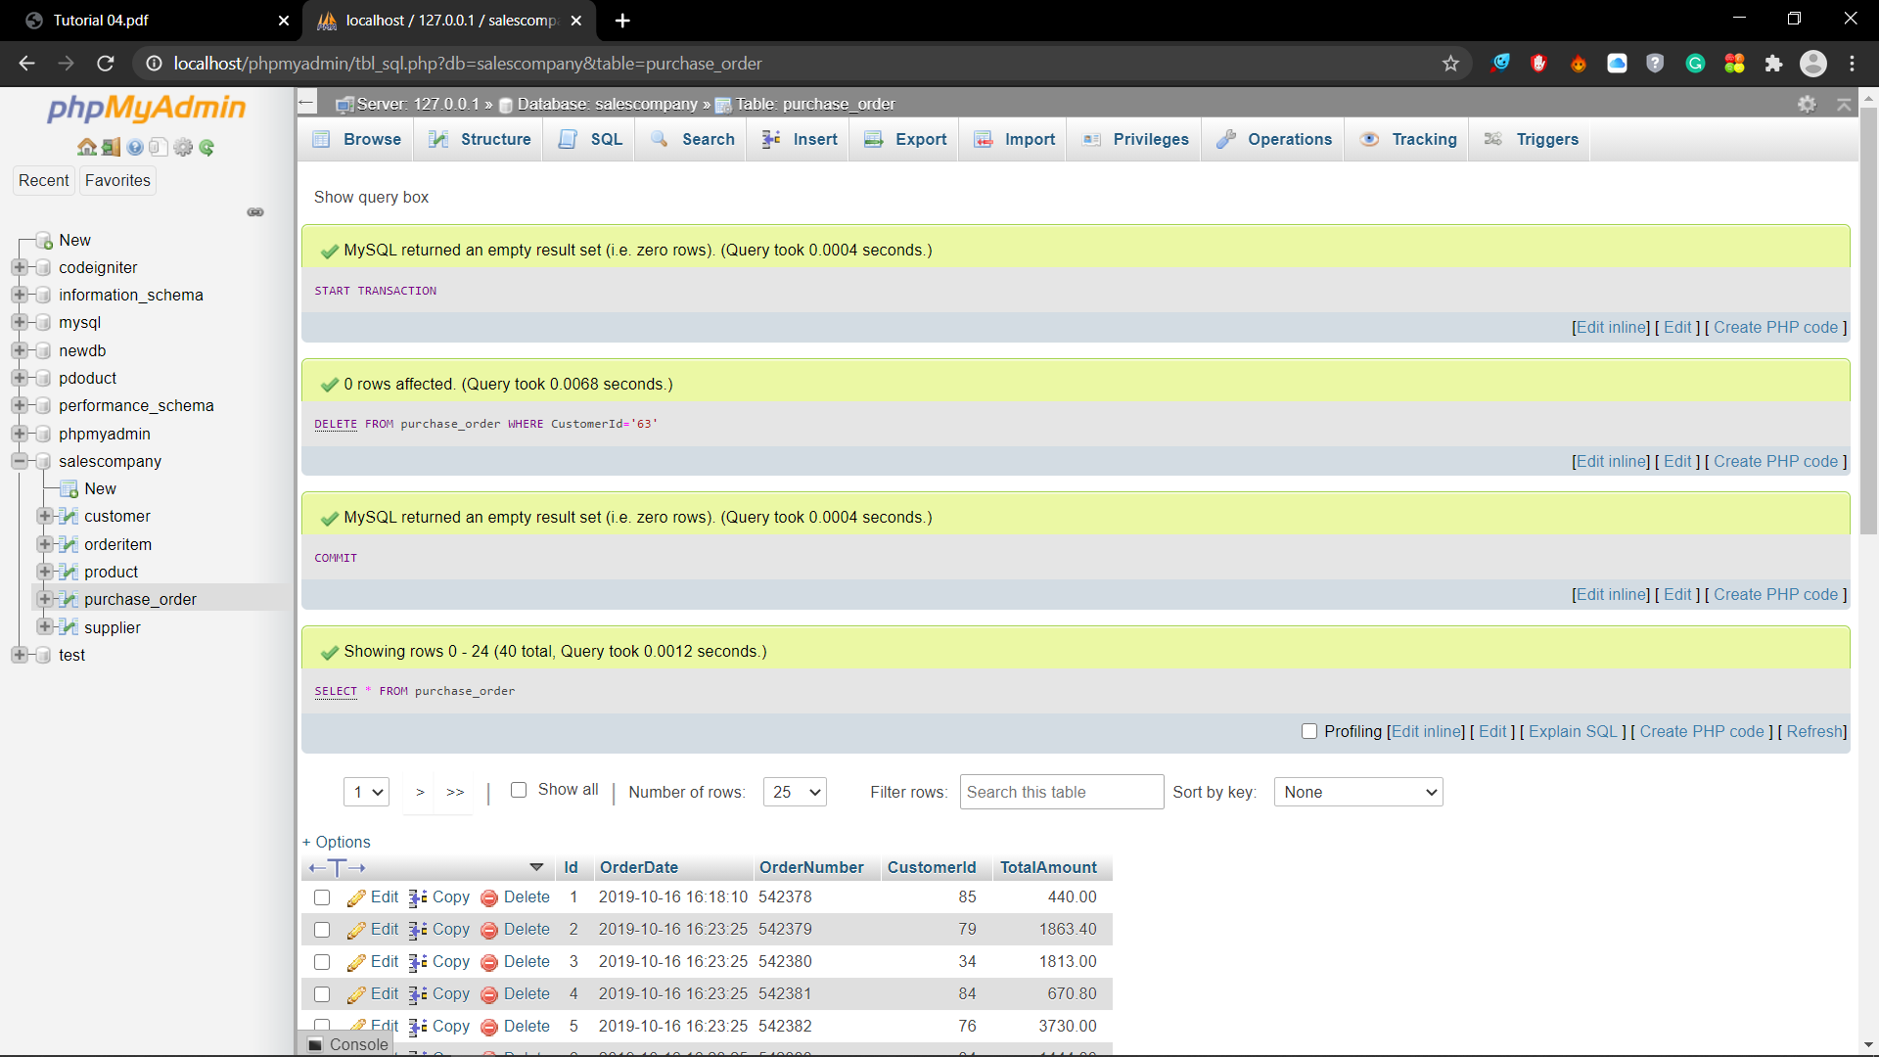

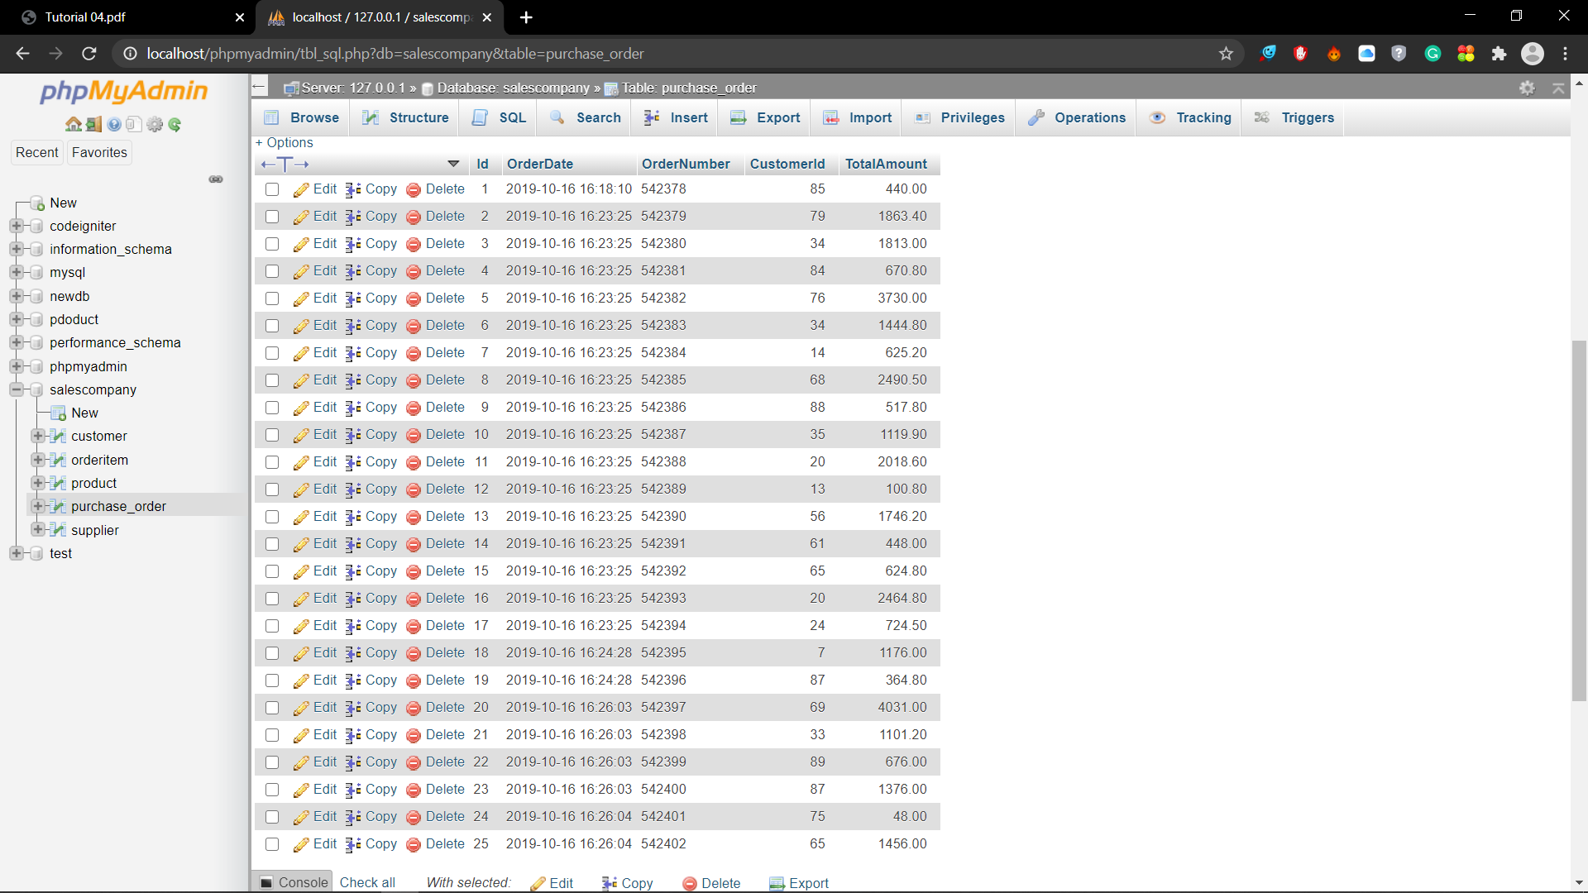

05)

START TRANSACTION;

DELETE FROM supplier

WHERE Id=(SELECT SupplierId FROM product WHERE ProductName='Chai');

ROLLBACK;

COMMIT;

SELECT * FROM supplier;

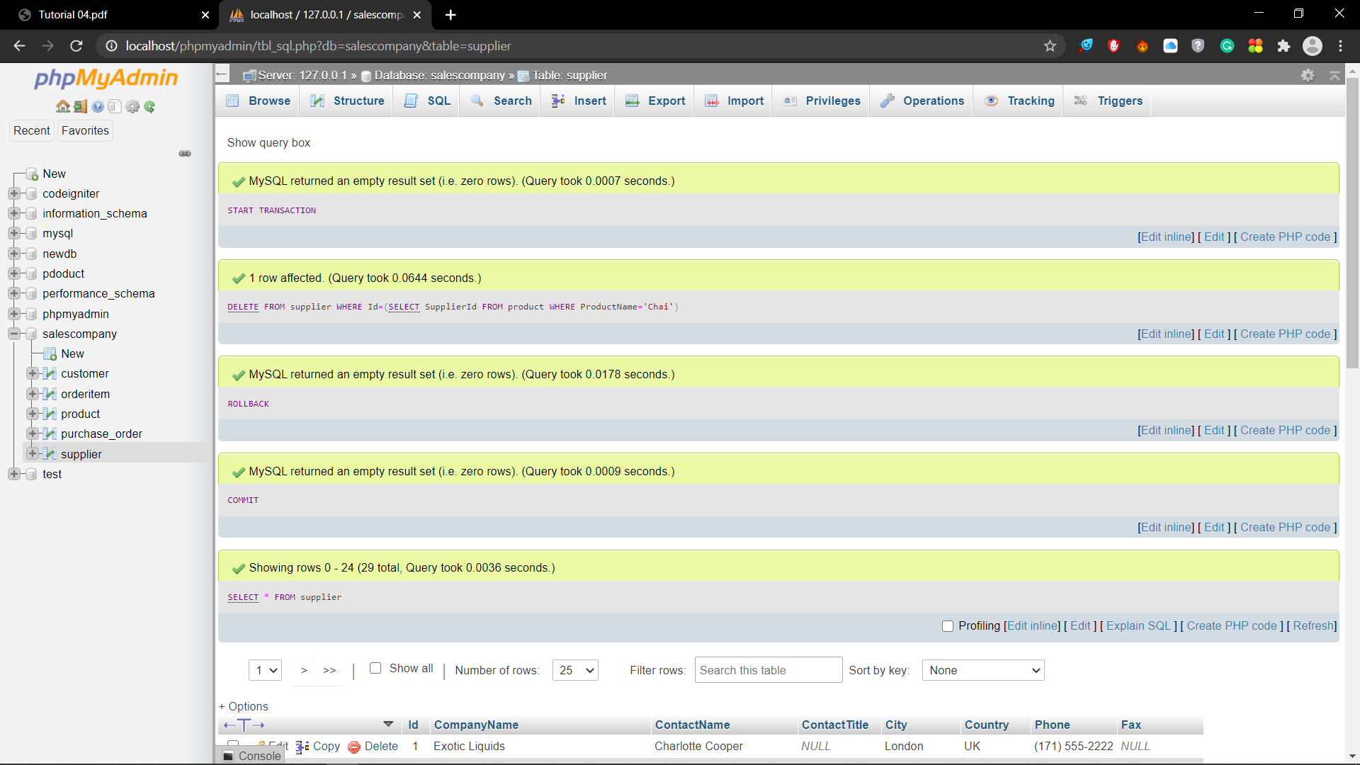

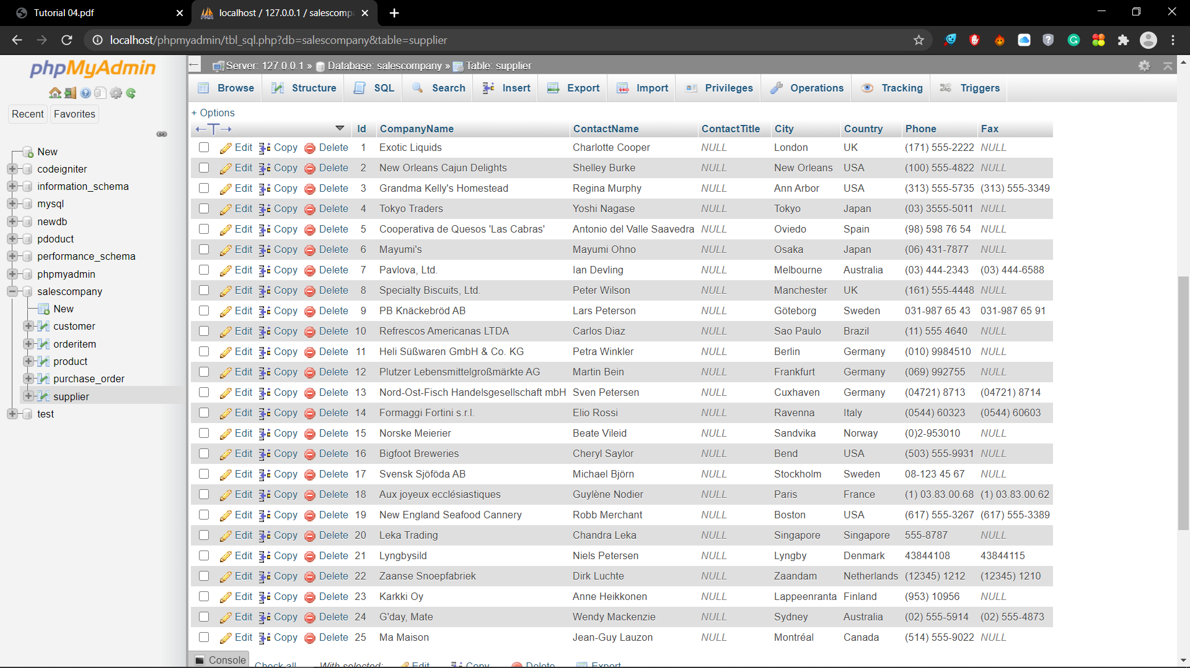

06)

START TRANSACTION;

UPDATE customer SET FirstName='Mary'

WHERE FirstName='Maria' AND Country='Germany';

COMMIT;

SELECT FirstName, Country FROM customer WHERE Country='Germany';

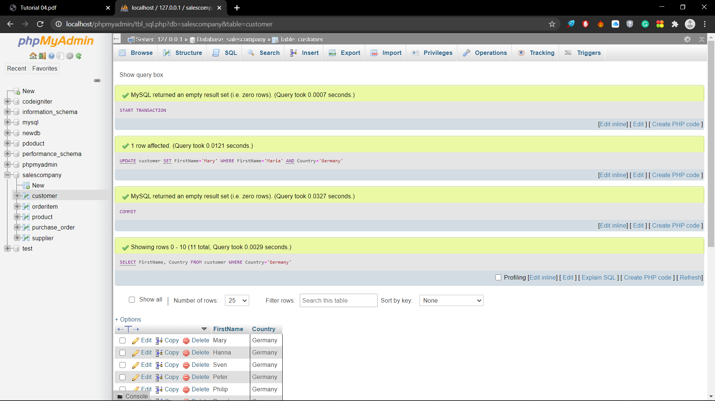

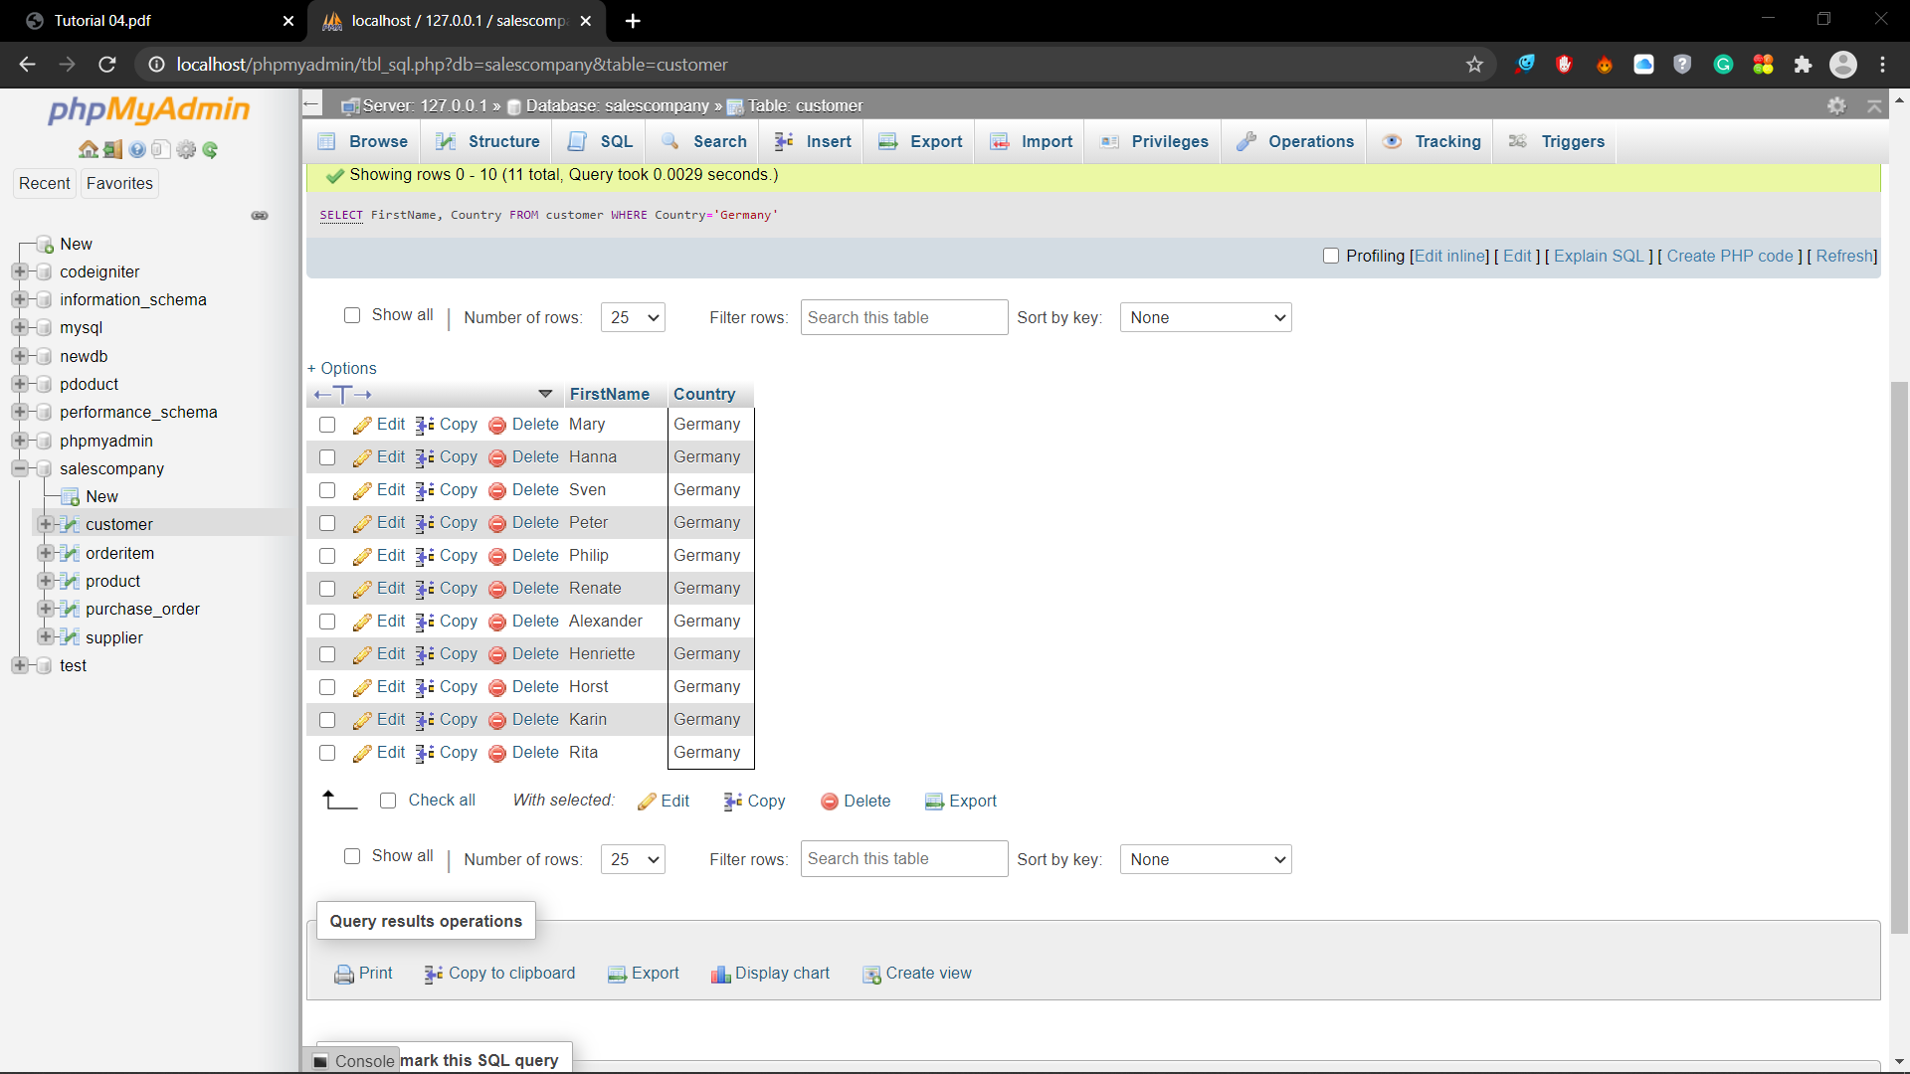

07)

START TRANSACTION;

UPDATE customer SET Phone='171-8885621' WHERE FirstName='Victoria';

SELECT * FROM customer WHERE FirstName='Victoria';

ROLLBACK;

SELECT * FROM customer WHERE FirstName='Victoria';

